**PROJECT REPORT**

**ON**

**FAKE REVIEW DETECTION**

**MADE BY**

**KARTEKAY KAUSHIK**

**UNDER GUIDANCE OF**

**MRS. ANAMIKA GUPTA**

**INTRODUCTION:**

This report explores the domain of fake review detection to address the escalating issue of dishonesty in online review systems. The report explores a range of topics, methodologies, and algorithms related to identifying and mitigating the impact of fake reviews on consumer decisions and the credibility of online platforms.

**PROBLEM STATEMENT:**

To run the algorithm on the created dataset to classify the reviews given as fake or real.

**STEPS FOLLOWED:**

1. Creation of dataset from amazon aN e-commerece site using web scrapping technique by using Beautiful Soup python library.
2. Testing the code to hundered percent functionality on given dataset(includes precprocessing the dataset,generating final dataset,sentiment score generation,generating the unique word count,part of speech tagging,authenticity of review measurement,model training,labelling reviews).
3. Determing which review is fake and which review is not fake by using the code which labels them and gives.
4. Generating the graph of ratio of fake and real reviews using the code.

**CONCLUSION:**

The different machine learning algorithms gave this result on model training:

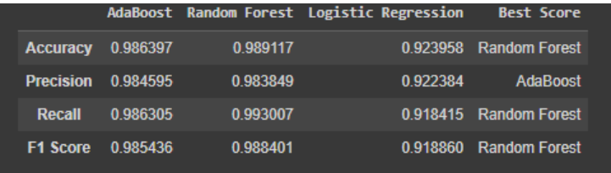

Distribution of fake and real reviews in the generated dataset:

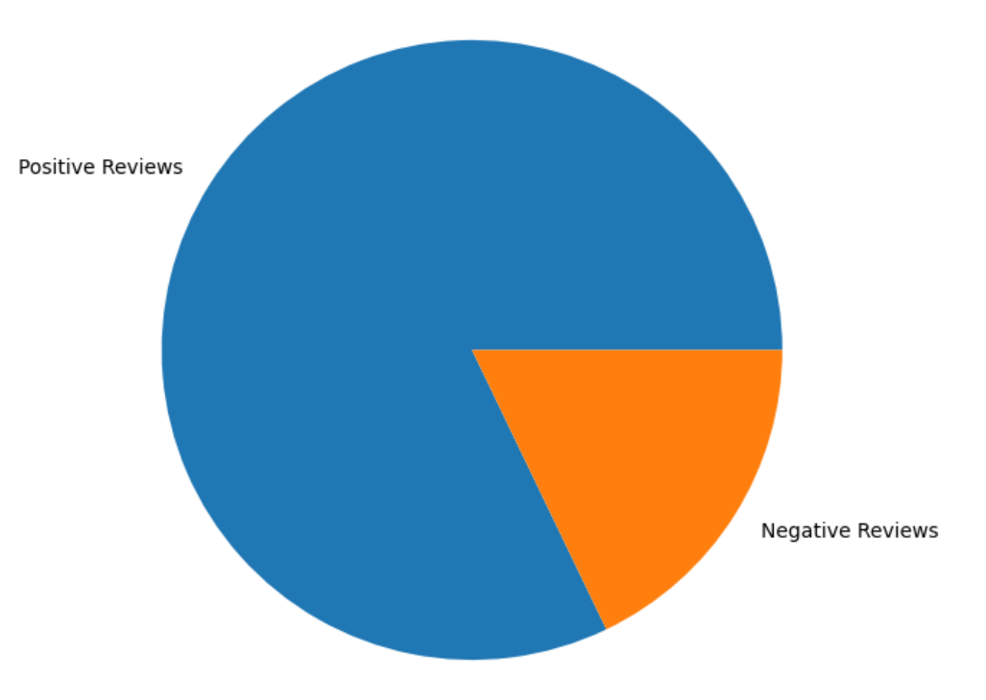

**REFERENCES:**

1. Source:

https://www.kaggle.com/code/crimsonred/fake-review-detection/notebook

2. Set Of Code:

https://colab.research.google.com/drive/14JcOf1ReFqWUvJJrttPv6YkjGSPtcuZK#sc rollTo=eXJ6ePpkhqoW

3. Data Set Used:

https://docs.google.com/spreadsheets/d/1b_PyCT3ciupfQ14wMnyQ8LwWD0XvoMj lpRdodVH6_r0/edit#gid=229086339

4. Use of Web Scrapping:

<https://colab.research.google.com/drive/12dyNuRPzsC3-qIgdNrqWgJks032-PkNx>

5. Output Result:

https://docs.google.com/spreadsheets/d/1zN3oI1QUqRyHlu_8wygZnnaNyBypTe613 BXStYo6Sqg/edit#gid=622919157